Cairns Botanic Gardens Visitors Centre

EXHIBITION TERMS & CONDITIONS
For exhibitions and displays in Interpretive Area and Multi-Purpose Room
EXHIBTION PARTICIPATION
The Botanic Gardens Visitors Centre (BGVC) invites exhibitions and displays that are based on the following themes:
- Botanical/Horticultural
- Environmental/Conservation
- Local community
Displays and exhibitions will be assessed for inclusion in the program if they adequately meet the following criteria
- respond to the identified themes
- display a high artistic or aesthetic value
- maintains a sound scientific basis
- includes elements of interactivity with its audience
- is informative, educational and entertaining
EXHIBITIONS IN THE BGVC ARE FREE OF CHARGE AND INCLUDE
- Display space and supply of plinths/hanging system.
- Assistance with installation of work into the exhibition space.
- Website and social media listing.
THE EXHIBITOR IS TO PROVIDE
- All artworks/artefacts prepared for installation
- Digital photographs for display on interpretive UHD television to be supplied at (16:9, 3840 x 2160 pixels) jpegs.
- Didactic information or artist’s statement about the exhibition
- Didactic information about each item requiring a label, including title, artist, year of completion, medium, sale price and any other conceptual or contextual information relating to the artwork/artefact. BGVC will supply spread sheet template.
- Marketing copy and images
- Exhibition launch (optional) at exhibitor’s expense.
SALES COMMISSION
Refers to the percentage to be deducted from the selling price of an Artwork/Artefact. Sales will be handled by BGVC staff and a commission of 30% will be retained by CRC.
DELIVERY OF ARTWORK/ARTEFACTS TO BGVC FOR EXHIBITION
Exhibitors are responsible for transporting their Artwork/Artefact to the BGVC for Exhibition/Display and from the BGVC if unsold.
INSURANCE
It is the responsibility of the exhibitor to insure the works at all times between
- The earliest arrival of artworks/artefacts date and time; and
- Whichever is the later:
  - If an item of the work is sold to a buyer – collection of the item of the works by the buyer in accordance of terms in Attachment A, and
  - If an item of work is not sold to a buyer – whichever is the later of collection of the item by the exhibitor in accordance of terms in attachment B.
- The BGVC accepts no responsibility for the theft of or damage to any item of the works which occurs during the exhibition/display.
MARKETING
The BGVC may undertake the following marketing activities for the benefit of the exhibitor.
- Inclusion of the exhibition or display in the ‘Around the Tanks’ section in Tanks programme; and
- Inclusion of the exhibition or display on Cultural Services social media pages.
For marketing purposes, the exhibitor must:
Deliver to The BGVC no later than the copy deadline for promotional text and images.
- At least 1 image for use on promotional material (3-5Mb, square format) with caption(title, artist, medium);
- Between 100 and 150 words about the exhibition; and
- All logos and acknowledgements required by the exhibitor and each sponsor of the exhibitor.
If the exhibitor is not the author of each of the works, the exhibitor must procure the consent of each author of a work for promotional purposes. However the exhibitor may notify the BGVC in writing if there is any work they do not want to be photographed.
The exhibitor is encouraged to conduct their own promotions of the exhibition, but must not produce any additional promotional material or undertake any promotional strategy without informing Cultural Services Marketing Team and gaining written approval.

Attachment A

CONDITIONS FOR THE EXHIBITION AND SALE OF ARTWORKS AT THE BOTANIC GARDENS VISITORS CENTRE

- All artwork (each an “item”) must be delivered to Botanic Gardens Visitors Centre, 64 Collins Avenue Edge Hill, on the date specifies in attachment B
- Each item must be delivered ready to hang or install and appropriately identified with a ticket showing the name of the Featured Artist and the title of the item.
- The item must remain on display in the Exhibition/Display Venue for the term of the Exhibition/Display.
- The role of Botanic Gardens Visitors Centre in any sale of an item is that of a sales agent. Botanic Gardens Visitors Centre will receive and hold the sale proceeds for each item on behalf of the Featured Artist or the agent of the Featured Artist.
- The Buyer of an item will be required to pay a 20% non-refundable deposit to secure the purchase of the item. Each Buyer of an item will be required to complete payment before the item may be collected by the Buyer. Should the Buyer fail to complete payment for an item, the item will be made available for collection by the Featured Artist at the close of the Exhibition. Each deposit received for the uncompleted sale of an item will remain the property of Botanic Gardens Visitors Centre.
- On completion of payment by a Buyer, a tax invoice will be issued by Botanic Gardens Visitors Centre on behalf of the Featured Artist or the agent as nominated by the Featured Artist (the “supplier”). If the supplier does not have an ABN, the supplier must complete and sign a “statement by a supplier” form (attached) and return it with this Artist’s Agreement.
- Processing of sale proceeds may take up to 28 days.
- Botanic Gardens Visitors Centre will retain from the sale proceeds for an item commission of 30% of the sale price, for which the supplier will be given a tax invoice.
- If an item is not sold during the Exhibition, it must be collected by the Featured Artist, or an agent of the Featured Artist, on the date specified in attachment B.
- Each of the Exhibitor, the Featured Artist and the agent (if any) must insure each item whilst the item is on display for the purposes of the Exhibition. Botanic Gardens Visitors Centre takes no responsibility for theft of or damage to an item during the Exhibition.
- Botanic Gardens Visitors Centre is not responsible for an item not collected during the collection period specified in paragraph 9. If any item remains uncollected two months after the end of the collection period specified in paragraph 9, Botanic Gardens Visitors Centre may give written notice to the Featured Artist of its intention to dispose of the item. If the item is not collected within one month after the date of receipt of the notice of intention to dispose of the item, the item becomes the property of Botanic Gardens Visitors Centre and Botanic Gardens Visitors Centre may dispose of the item in any way it chooses.
- The obligations of the Featured Artist specified in this Artist’s Agreement are obligations accepted by the Featured Artist for the benefit of Cairns Regional Council trading as Botanic Gardens Visitors Centre within the meaning of section 55 of the Property Law Act 1974 and the Featured Artist acknowledges having been advised of acceptance by Cairns Regional Council as beneficiary of the benefit of the obligations.
- If an expression is defined in the Exhibition Contract entered into between Cairns Regional Council trading as Botanic Gardens Visitors Centre and the Exhibitor and used in this Artist’s Agreement, the expression has the same meaning in each of the Exhibition Contract and this Artist’s Agreement.

Attachment B
BGVC Exhibition/Display Agreement

EXHIBITOR CONTACT DETAILS
Exhibitor:
Contact person:
Address:
Phone:
Email:
Will display items be for sale: Yes/No
If yes, are you an existing Council Supplier? Yes/No/Not sure
IMPORTANT DATES
Marketing copy deadline:
Delivery of display items:
First day of exhibition:
Opening times: 8.30am – 4.30pm Monday – Friday, 8.30am – 2.30pm Saturday and Sunday
Last day of exhibition:
Collection of display items:

I agree to the attached Exhibition Terms and Conditions

Exhibitor (name) Signature Date

CRC (name) Signature Date

TO BE COMPLETED BY EACH FEATURED ARTIST OR THEIR AGENT WHEN WORKS ARE FOR SALE UNLESS THEY ARE AN EXISTING SUPPLIER TO COUNCIL
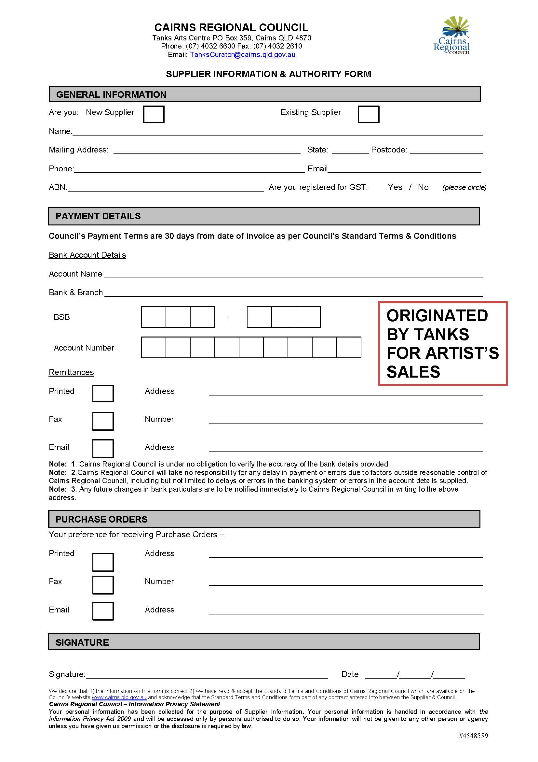
TO BE COMPLETED BY EACH FEATURED ARTIST IF THEY DO NOT HAVE AN ABN

