PO Box 359 Cairns Q 4870
46 Collins Ave, Edge Hill Q 4870 www.tanksartscentre.com
P: 07 4032 6609 F: 07 4032 2610 info@tanksartscentre.com

No. 5 COLLINS AVENUE RESIDENCE

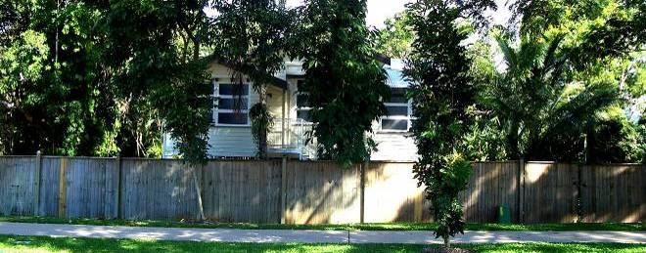

OVERVIEW

The Cairns Botanic Gardens precinct takes in Flecker Gardens, Centenary Lakes and Tanks Arts Centre and is known for its unique blend of tropical gardens, iconic architecture, historical value and contemporary arts program.

The residence is situated on the periphery of the Gardens precinct, and adjacent to Saltwater Creek. The newly refurbished four bedroom 1970’s Queenslander home, sits amongst towering mango trees, with a large balcony overlooking the extensive tropic garden.

The house is offered as short to medium term accommodation (2 weeks – 3 months) for the Multi-Arts Residency program, and for the accommodation needs of artists and performers engaged in our program of events. It is also available for worker exchanges and internships; artists or arts/cultural workers visiting the region for research or work hosted by other arts and cultural organisations. This includes: horticulturists, scientists, mathematicians, musicians, writers, curators, filmmakers, actors, designers and dancers.

The program’s objective is to offer a socially and creatively conducive environment in which artists can live and work; to attract professional and student artists and scientists from around the world to experience the region and exchange ideas.

Cross-disciplinary interaction and collaboration is highly encouraged. Applicants may share the accommodation with other resident artists and/or scientists, though this is not enforceable.

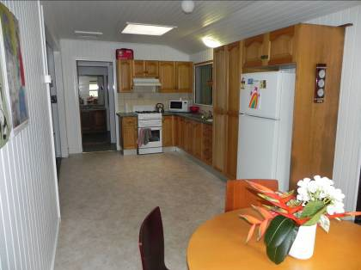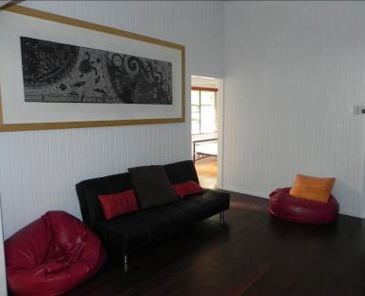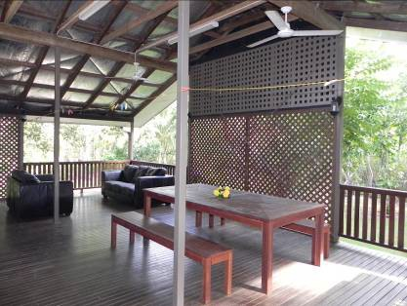

1 #4425268

MUTLI-ARTS RESIDENCY PROGRAM

The Tanks Arts Centre is an iconic and innovative, multi-use, contemporary arts facility creatively housed in three converted World War II naval oil storage tanks, and set amidst a lush rainforest backdrop.

Tanks Arts Centre offers a flexible residency program not only in the visual arts, but also in music, writing, multimedia and community cultural development for short and long term projects that have a connection to, or presentation outcome at Tanks. Artists taking up residencies at the Tanks will find a variety of interesting spaces to work amongst the original oil-stained poles and vast Tanks 3 and 4, in our secluded and airy studio hut and within the grounds of the Botanic Gardens.

We encourage creative ideas from local, national and international artists and local community groups who wish to work with artists. Living accommodation and studio space is available as part of the residency program.

The Residency Program is ongoing: there are no application deadlines. For more information see the: Multi-Arts Residency Guidelines & Application Form.

TENANCY AGREEMENTS

Tenancy Agreements for periods of 2 weeks to 3 months may be entered into between the Tanks Arts Centre and artists participating in the Tanks multi-arts residency program. For artists being hosted by other organisations, the tenancy agreement must be made between the Tanks Arts centre and the host organisation. All rental fees must be paid in advance.

Individual/Room: $138.75/week.
Group/Entire house (max 5): $231.20/week
Tenants will be expected to do their own house keeping, but the house will be visited by a janitor/cleaner once a week. Applicants with family members will be considered, however, pets and other animals are not permitted.

Any waiving of fees and charges can be granted through Council’s In-Kind Grants Program. Applications for both In-Kind and other Cairns Regional Council grants are available from Council’s website:

http://www.cairns.qld.gov.au/
data/assets/pdf_file/0012/11721/ACInKind.pdf

Projects that are initiated by the Tanks in partnerships with artists or community organisations may be exempt from fees and charges.

For Tanks’ venue hire and exhibition costs, please visit www.tanksartscentre.com .

THE FACILITIES

The self-contained house is situated at No. 5 Collins Ave, Edge Hill Cairns. It contains four bedrooms (some air-conditioned), an open plan kitchen and dining area, a bathroom and toilet, a furnished studio area for office based work and a large outdoor balcony.

Beneath the house features an enclosed space for residents to carry out home-based creative activity, including sculptural works, painting, etc. The yard may be used for resident artists to build sculptural works.

The house is fully furnished including: washing machine, television, kitchenware, linen, office desks, chairs and a work bench. There is a phone and an internet connection.

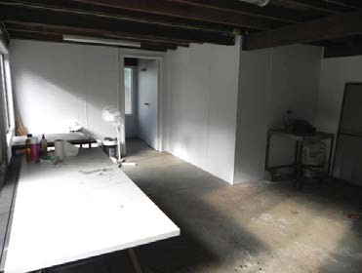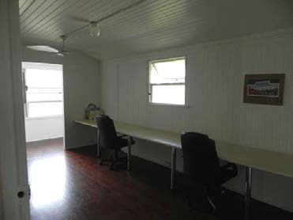

RESTRICTIONS

The studio space, both upstairs and downstairs, is only to be used by those in residence at the house. In addition, it may not be considered the primary workplace for the work they are undertaking in the residency or research project they are engaged in. Artist run workshops on- site, community meetings or using the work space for the purposes of conducting a business is also not permitted.

These restrictions do not prohibit residents from utilising the studio, or any other part of the house or yard for creative work that contributes to the body of work they are engaged in through their residency or research project.

There residence can house a maximum of five people at any given time. The studio space underneath the house may not be used as living space.

CRITERIA FOR ASSESSING APPLICATIONS

1. No. 5 Collins Avenue is owned by Cairns Regional Council and managed by the Tanks Arts Centre. Its gardens are managed and maintained by Cairns Botanic Gardens. The primary purpose of the house is to accommodate artists, horticulturalists and scientists hosted by the Tanks and Botanic Gardens.

2. Consideration is given to the benefit of the residency to the community, the arts sector, the pursuit of botanical research and the host organisation.

3. Length of stay is considered as it equates directly to cost saving for the host organisation. Most short-stay residencies are merely easier with subsidised accommodation, while longer projects would be impossible without it.

4. Flexibility of the term of the residency is an important factor in scheduling proposed residencies. Some residencies are fixed to dates which cannot be changed (e.g. Cairns Festival). Applications may be approved conditional upon availability.

5. Applications from tenants who are willing to share the house with other tenants, working on separate residency projects, are generally easier to accommodate and provide for a more homely, social and community-connected experience for the tenants.

6. New applicant organisations are encouraged. The house is accessible to all organisations wishing to host a residency project in Cairns.

PO Box 359 Cairns Q 4870
46 Collins Ave, Edge Hill Q 4870 www.tanksartscentre.com
P: 07 4032 6609 F: 07 4032 2610 info@tanksartscentre.com

RESIDENCE APPLICATION FORM

Please list the name and occupation of applicant(s), please include family members
Full name |  | Occupation
Click here to enter text. |  | Click here to enter text.
Click here to enter text. |  | Click here to enter text.
Click here to enter text. |  | Click here to enter text.
Organisation | Click here to enter text.
Contact Person | Click here to enter text.
Address | Click here to enter text.
Phone | Click here to enter text.
Mobile | Click here to enter text.
Email | Click here to enter text.

Proposed dates: Click here to enter text. To Click here to enter text.

Participating organisation(s):

Click here to enter text.

What are the aims of your residency?

Click here to enter text.

What will be the benefits for your organisation and/or the community?

Click here to enter text.

4 #4425268

Do you require use of the

Downstairs studio area
Upstairs studio area
Yard

Do you have any special requirements?

Click here to enter text.

Supporting funding bodies (if any)?

Click here to enter text.

On what date would you be able to sign a tenancy agreement?
Click here to enter a date.
How many bedrooms will you need?
Click here to enter text.
Would you consider a share accommodation with another tenant or group of tenants if approached?

Click here to enter text.

5 #4425268

