Single-use eating and drinking utensils are the biggest source of waste at most festivals and community events. Used for just a few minutes, these products don’t need to be made from plastic, a product that is designed to last forever.

As a prospective food / drink vendor, you have a vital role to play in reducing this events environmental footprint by adhering to the following waste-wise condition:
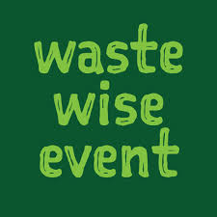
Vendors must use certified compostable eating and drinking utensils, excluding bottles and cans, and must not distribute plastic bags of any thickness, plastic straws, cutlery, containers, plates, cups, bowls, sachets (such as sauce packets), polystyrene (foam) packaging or trays, balloons or non-compostable coffee cups.

By applying to attend this event, you are accepting this waste-wise condition and acknowledge that failure to adhere to this conditions may impact your ability to participate at current and future events.

Applicant details
Business name
Contact name |  | Phone
Email

Type of mobile premises (please tick)
Caravan |  | Trailer |  | Marquee |  | Other

Space requirements (i.e. length and width of your stall)
 | X |  | metres

Water requirement (please tick)
None |  | Intermittent use of tap |  | Other

Power requirement (please specify how many of each) generators & gas bottles are not to be used without prior approval
10 amp X |  | 15 amp X |  | Other

Proposed Menu (include mention of any locally grown produce and pre-packaged food / drinks)
Standard approvals (please include copy of each document with application)
I have attached a current Queensland Food License
I have attached a current Certificate of Currency for Public Liability Insurance for a value exceeding $20,000,000

Signed: |  | Date:

